

**Western Australian Certificate of Education**

**ATAR course examination, 2017**

**Question/Answer Booklet**

11 PHYSICS

Name

**Test 4 - Heating and**

**Cooling**

|  |  |  |  |  |  |  |  |  |  |  |
| --- | --- | --- | --- | --- | --- | --- | --- | --- | --- | --- |
| Student Number: In figures |  |  |  |  |  |  |  |  |  |  |

**Mark:**  In words

#### Time allowed for this paper

Reading time before commencing work: five minutes

Working time for paper: fifty minutes

**Materials required/recommended for this paper**

To be provided by the supervisor

This Question/Answer Booklet

Formulae and Data Booklet

***To be provided by the candidate***

Standard items: pens, (blue/black preferred), pencils (including coloured), sharpener, correction fluid/tape, eraser, ruler, highlighters

Special items: non-programmable calculators satisfying the conditions set by the School Curriculum and Standards Authority for this course

**Important note to candidates**

No other items may be taken into the examination room. It is your responsibility to ensure that you do not have any unauthorised notes or other items of a non-personal nature in the examination room. If you have any unauthorised material with you, hand it to the supervisor before reading any further.

**Structure of this paper**

|  |  |  |  |  |  |
| --- | --- | --- | --- | --- | --- |
| Section | Number of questions available | Number of questions to be answered | Suggested working time  (minutes) | Marks available | Percentage of exam |
| Section One:  Short Answers | 6 | 6 | 15 | 11 | 42 |
| Section Two:  Problem-solving | 4 | 4 | 35 | 15 | 58 |
| Section Three:  Comprehension |  |  |  |  |  |
|  |  |  |  | **Total** | 100 |

**Instructions to candidates**

1. The rules for the conduct of examinations at Holy Cross College are detailed in the College Examination Policy*.* Sitting this examination implies that you agree to abide by these rules.

2. Write your answers in this Question/Answer Booklet.

3. Working or reasoning should be clearly shown when calculating or estimating answers.

4. You must be careful to confine your responses to the specific questions asked and to follow any instructions that are specific to a particular question.

5. Spare pages are included at the end of this booklet. They can be used for planning your

responses and/or as additional space if required to continue an answer.

• Planning: If you use the spare pages for planning, indicate this clearly at the top of the page.

• Continuing an answer: If you need to use the space to continue an answer, indicate in the original answer space where the answer is continued, i.e. give the page number.

Fill in the number of the question(s) that you are continuing to answer at the top of the page.

6. Answers to questions involving calculations should be ***evaluated and given in decimal***

***form*.** It is suggested that you quote all answers to ***three significant figures***, with the

exception of questions for which estimates are required. Despite an incorrect final result, credit may be obtained for method and working, providing these are ***clearly and legibly set out***.

7. Questions containing the instruction "estimate" may give insufficient numerical data for their solution. Students should provide appropriate figures to enable an approximate solution to be obtained. Give final answers to a maximum of two significant figures and include appropriate units where applicable.

8. Note that when an answer is a vector quantity, it must be given with magnitude and direction.

9. In all calculations, units must be consistent throughout your working.

**DATA**

Use the data sheet plus the following table.

Table

1. Explain why a pump gets hot while you pump up a bicycle tyre or a football with it. [2 marks]

2. Which of the following statements are ***true***?

**I** A temperature of 50º C is the same as a temperature of 50 K.

**II** A temperature rise of 50º C is the same as a temperature rise of 50 kelvin.

**III** A temperature fall of 50º C is the same as a temperature fall of 50 kelvin.

A. I and II only

B. I and III only

C. II and III only

D. I, II and III [1 mark]

3. Four identical beakers **I, II, III and IV** are placed on a large electric hotplate. **I** and **II** are

half-full and **II** and **IV** are full of tap water at the same initial temperature. **I** and **IV** are placed on the hotplate for 2.5 minutes, **III** is left on for 5 minutes and **II** is left on for 10 minutes. At the end of each of these periods, the particular beaker is removed from the hotplate. The water does not boil in any of the beakers.

*Half Full Half Full Full Full*

*2.5 minutes 10 minutes 5 minutes 2.5 minutes*

**I II III IV**

A. Which one of the beakers of water will absorb the greatest amount of heat in total?

[1 mark]

B. Which one of the beakers of water will have the lowest temperature immediately after being heated? [1 mark]

C. Which two beakers of water will have almost the same final temperature after being heated? [2 marks]

4. An experiment was carried out in which some solid naphthalene crystals were warmed in a test tube. The graph below represents the results obtained.

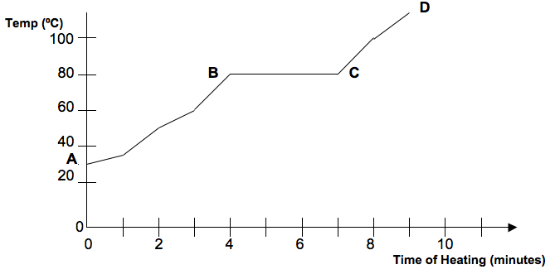

A. Referring to the graph, what phase/s would be present between **C** and **D**?

[1 mark]

B. How long did it take the naphthalene to melt? [1 mark]

C. Latent heat is being absorbed during the period represented on the graph by which line?

[1 mark]

5. Use the Kinetic Theory to explain the difference between ***heat*** and ***temperature***.

[2 marks]

6. Explain why a person standing in a breeze is more likely to feel cold if their clothes are wet rather than dry.

[2 marks]

7. At the end of a marathon run, an athlete’s body temperature may be 3.2 ºC above normal body temperature.

If the mass of the athlete is 55.0 kg, how much energy is required to produce this change in temperature?

***(Assume the average specific heat of the athlete is 3.50 x 103 Jkg-1C-1)***

[3 marks]

8. In an experiment to determine the specific heat of an unknown metal, a 1.15 x 102 g sample at 1.50 x 102 ºC is placed carefully into a 70.0 g copper calorimeter containing 90.0 g of water, initially at 15.0 °C. If the final temperature reached is 27.0 °C, determine the specific heat of the metal.

[4 marks]

9. A copper calorimeter of mass 1.00 x102 g contains 4.00 x 102 g of water at 40.0 º C. When 91.0 g of ice at 0.00º C is added, the final temperature of the water is 18.2º C.

Use this information to determine the latent heat of fusion of water. ***Assume that there is no heat loss to the environment.***

[4 marks]

10. An electric kettle's heating element has a power rating of 2.10 kW. If its transfer of energy to the water is 60.0% efficient, calculate how long it would take to boil away 1.10 kg of water initially at 20.0 °C.

***(Assume the heat absorbed by the kettle is negligible.)***

[4 marks]